HEADLINE
The Biggest Players in the Pickle Market

DEK
These pickle moguls are defining the brine of the market.

SLUG
biggestplayers

MAIN IMAGE (link to image in Header Image drive)
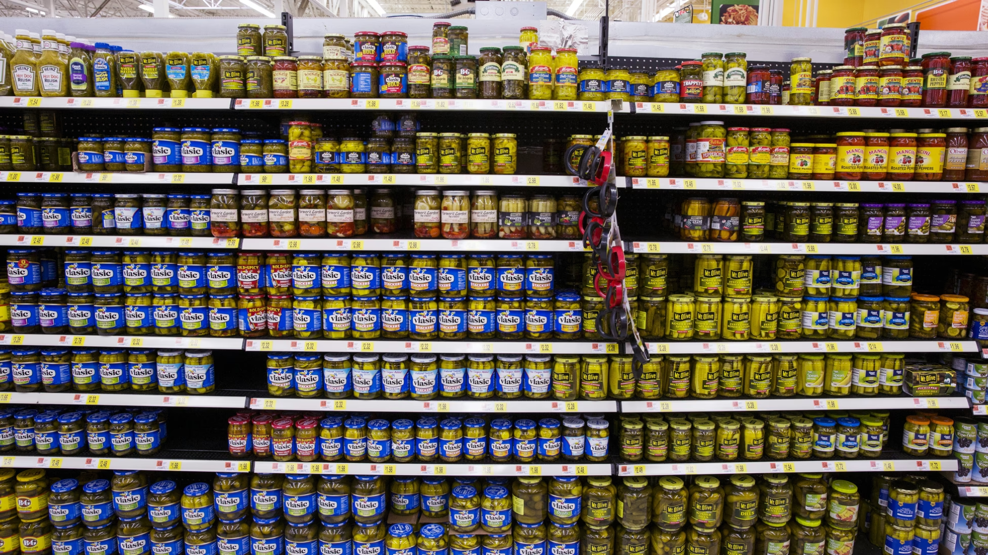
Issue 19 Header Image

MAIN IMAGE CREDIT
From The Atlantic, by Lucas Jackson

PUBLISHING DATE
June 3rd, 2026

AUTHOR
Rachel Manson

PROSE
In 2025, the global pickle market was valued at 26.64 billion USD, and it’s projected to grow to nearly 30 billion USD by the end of 2026. At the head of the table, these captains of the salty industry determine pickle market trends, sales, and accessibility of the brands that make it to the shelf of grocery stores nationwide.
Here are the top players defining the future of the pickle market today:
*Note: This article is part of a two-part series. Stayed tuned for another installment in a few weeks.

Bobby Frye - CEO of Mt. Olive Pickle Co.
Bobby Frye is the President and CEO of the Mt. Olive Pickle Company, the largest independent pickle company in the U.S. Mt. Olive Pickles are a household name, with the company turning 100 years old in 2026. They produce over 230 million jars annually and dominate the market as America’s best-selling brand of pickles, peppers, and relishes. Frye has led the company as CEO since 2015, but he is a long-term veteran of the company, as Frye’s grandmother, Birdie, was a Mt. Olive Pickle Co. sales legend dating back to 1933.

John Brase - President and CEO of Conagra Brands
While pickle fans may not be familiar with the name Conagra, they might be familiar with the company's acquired pickle brand: Vlasic. Vlasic is the second most popular pickle brand in America, after Mt. Olive. Conagra Brands, a major Chicago-based food company, acquired Vlasic through its purchase of Pinnacle Foods in 2018. John Brase has been the president and CEO of Conagra since June 1, 2026, bringing with him experience from his previous role as the chief operating officer of the J.M. Smucker Company (Smuckers, Jif, etc.).

Steve Cahillane - CEO of Kraft Heinz & Claussen
Steve Cahillane is the Chief Executive Officer of The Kraft Heinz Company as of January 1, 2026. Kraft Heinz owns Claussen pickles, the third best-selling pickle company in the U.S. Claussen pickles started as a small pickle brand out of Woodstock, Illinois, and operated there for over 40 years before being acquired in the merger. Cahillane currently oversees both Claussen and Heinz Sweet Relish, a massive undertaking. But it easily streamlines the Claussens' cut pickle tips as a source for the Heinz relish, which is apparently how large companies manufacture relish, according to pickle master Bob McClure (featured on next week’s list).

Jorge Azevedo - CEO of Fermented Food Holdings
While consumers may still picture a Bubbie, jarring her famous family pickles in her home kitchen, Bubbies Pickles is owned by Fermented Food Holdings (FFH), which acquired the brand in December 2021. Jorge Azevedo, the CEO of FFH, was first a founding partner and chief growth officer at Planterra Foods, a plant-based start-up, and held a senior leadership role at Kraft Heinz as Head of U.S. Sales Execution and Finance. Looks like some of these pickle bigwigs might be connected in more ways than just a passion for pickles and a love of upward stock trends.
A special shoutout to the real Bubbie behind the brine: Leigh Truex, the Bubbie who began selling her homemade, naturally fermented Kosher Dill Pickles at local stores and farmers' markets in California back in 1982.
Interested in more underdogs and innovators like Leigh Truex? Stay tuned to find out more about the local business owners who made it big in the pickle scene.

PICKLE ECONOMICS TITLE
Pie Chart of Pickle Cucumber Growing in U.S.

GRAPH (Issue 19 Graph / All Pickle Graphs)
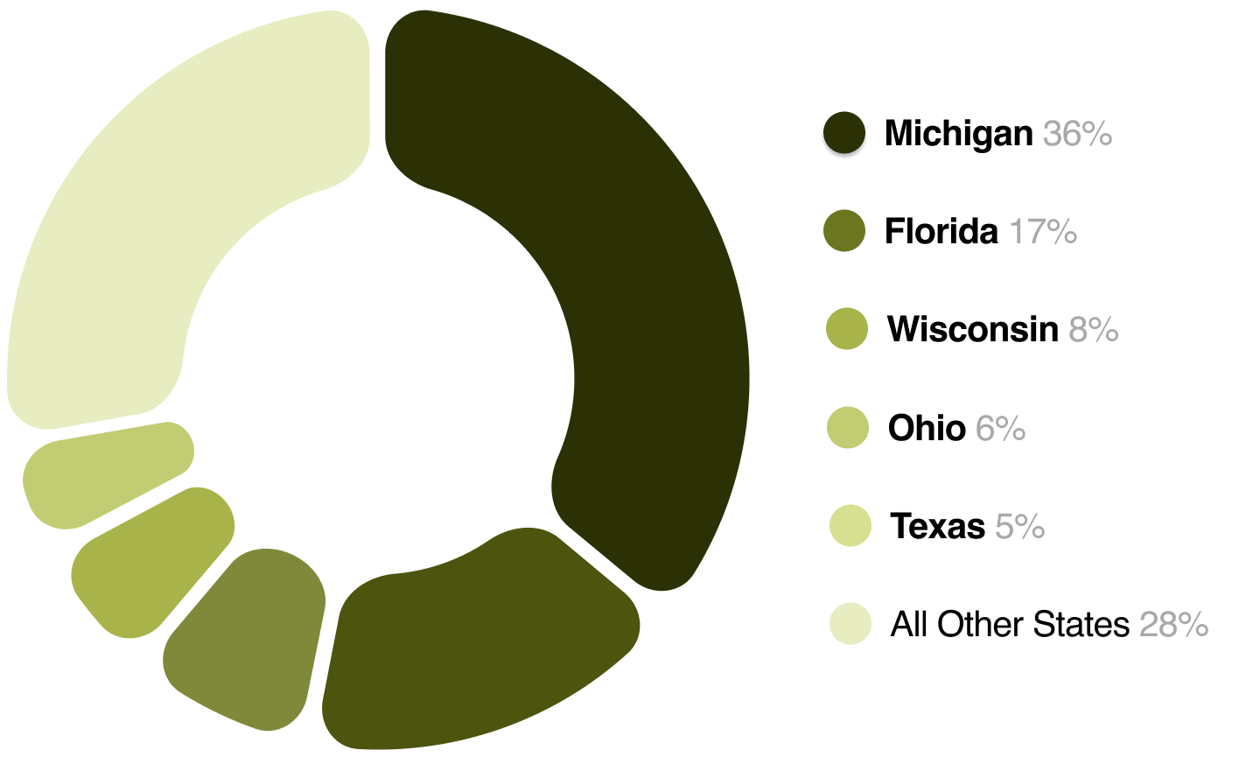

CREDIT / COURTESY LINE
Michigan State University

GRAPH INFORMATION URL
https://www.canr.msu.edu/cea/uploads/files/us%20fresh%20pickling%20cucumber%20markets.pdf

NIBBLES (secondary sources)

ITEM 1
100 years ago, 13 neighbors pooled $19,500 to save surplus cucumbers. Now they sell 230 million jars a year.
Mt. Olive
https://www.mtolivepickles.com/celebrating-100-years-of-mt-olive-pickle-company-a-century-at-the-corner-of-cucumber-vine/
ITEM 2
The birthrate was dropping in 1974. Vlasic saw an opportunity — and a stork got a new job.
Mental Floss
https://www.mentalfloss.com/article/64109/why-vlasic-pickles-mascot-stork
ITEM 3
Bubbies just solved the messiest problem in snacking: the pickle. Meet the first clean-label, grab-and-go pouch.
Yahoo
https://finance.yahoo.com/news/bubbies-redefines-snacking-pickle-first-163500018

SEXY PIC(KLE) OF THE WEEK (Issue 19 Sexy Pic(kle) / All Sexy Pic(kle)s)
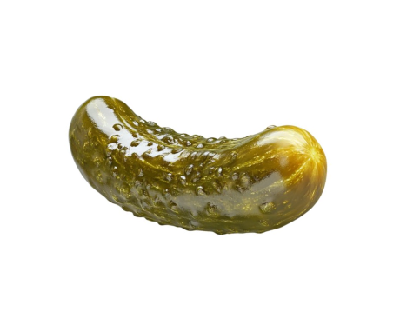

CREDIT
Pinterest (@robynclayton)

TODAY’S PICKLE TRIVIA (answer highlighted in yellow)
QUESTION
Of the four brands in today’s article, which one must be kept refrigerated even before opening?
OPTION A
Vlasic
OPTION B
Bubbies
OPTION C
Claussen
OPTION D
Mt. Olive
CORRECT ANSWER
C

LAST WEEK’S PICKLE TRIVIA (answer highlighted in yellow)
QUESTION
Which of these items is NOT on the KFC UK Pickled Menu?
OPTION A
Pickle Burger
OPTION B
Pickle Pepsi
OPTION C
Frickles
OPTION D
Pickle Lemonade
CORRECT ANSWER
D

ISSUE #
19

EMAIL SUBJECT LINE
The Biggest Players in the Pickle Market

EMAIL PRE-HEADER
These pickle moguls are defining the brine of the market.

